**PEMROGRAMAN 4**

**LAPORAN PRAKTIKUM 2**

Nama : Aldi Reza Sastrawan

Npm : 4513210004

Matkul : Pemrgoraman 4

1. Project Maven Membuat Tanggal dan Waktu & Database Produk menggunakan JSTL

**Produk.jsp**

<%--

Document : produk

Created on : Apr 16, 2016, 10:02:35 PM

Author : Aldi Reza Sastrawan

--%>

<%@page import="java.util.*"%>

<%@page contentType="text/html" pageEncoding="UTF-8"%>

<%@ page import="javax.servlet.*,java.text.*" %>

<%@ taglib prefix="x" uri="http://java.sun.com/jsp/jstl/xml" %>

<%@ taglib prefix="fn" uri="http://java.sun.com/jsp/jstl/functions" %>

<%@ taglib prefix="sql" uri="http://java.sun.com/jstl/sql_rt" %>

<%@ taglib prefix="c" uri="http://java.sun.com/jstl/core_rt" %>

<!DOCTYPE HTML PUBLIC "-//W3C//DTD HTML 4.01 Transitional//EN"

"http://www.w3.org/TR/html4/loose.dtd">

<html>

<center>

<h2>DAFTAR PRODUK</h2>

</center>

<sql:setDataSource var="snapshot"

driver="com.mysql.jdbc.Driver"

url="jdbc:mysql://localhost/daftar_produk"

user="root" password=""/>

<sql:query dataSource="${snapshot}" var="result">

SELECT * FROM produk

</sql:query>

<table border="1" width="100%">

<tr>

<th>ID</th>

<th>Kode</th>

<th>Nama</th>

<th>Harga</th>

<th>Teakhir Update</th>

</tr>

<c:forEach var="row" items="${result.rows}">

<tr>

<td><c:out value="${row.id}"/></td>

<td><c:out value="${row.kode}"/></td>

<td><c:out value="${row.nama}"/></td>

<td>Rp. <c:out value="${row.harga}"/></td>

<td><c:out value="${row.terakhir_update}"/></td>

</tr>

</c:forEach>

</table>

<center>

<h1>Tanggal dan Waktu</h1>

</center>

<%

Date dNow = new Date( );

SimpleDateFormat dt = new SimpleDateFormat ("E yyyy.MM.dd ");

SimpleDateFormat ft = new SimpleDateFormat ("hh:mm:ss");

out.print( "<h2 align=\"center\">Hari dan tanggal saat ini " + dt.format(dNow) + "</h2>");

out.print( "<h2 align=\"center\">Waktu saat ini " + ft.format(dNow) + "</h2>");

%>

</html>

**Pom.xml**

<?xml version="1.0" encoding="UTF-8"?>

<project xmlns="http://maven.apache.org/POM/4.0.0" xmlns:xsi="http://www.w3.org/2001/XMLSchema-instance" xsi:schemaLocation="http://maven.apache.org/POM/4.0.0 http://maven.apache.org/xsd/maven-4.0.0.xsd">

<modelVersion>4.0.0</modelVersion>

<groupId>com.aldirezasastrawan</groupId>

<artifactId>praktikum2</artifactId>

<version>1.0-SNAPSHOT</version>

<packaging>war</packaging>

<name>praktikum2</name>

<properties>

<endorsed.dir>${project.build.directory}/endorsed</endorsed.dir>

<project.build.sourceEncoding>UTF-8</project.build.sourceEncoding>

</properties>

<dependencies>

<dependency>

<groupId>javax</groupId>

<artifactId>javaee-web-api</artifactId>

<version>7.0</version>

<scope>provided</scope>

</dependency>

</dependencies>

<build>

<plugins>

<plugin>

<groupId>org.apache.maven.plugins</groupId>

<artifactId>maven-compiler-plugin</artifactId>

<version>3.1</version>

<configuration>

<source>1.7</source>

<target>1.7</target>

<compilerArguments>

<endorseddirs>${endorsed.dir}</endorseddirs>

</compilerArguments>

</configuration>

</plugin>

<plugin>

<groupId>org.apache.maven.plugins</groupId>

<artifactId>maven-war-plugin</artifactId>

<version>2.3</version>

<configuration>

<failOnMissingWebXml>false</failOnMissingWebXml>

</configuration>

</plugin>

<plugin>

<groupId>org.apache.maven.plugins</groupId>

<artifactId>maven-dependency-plugin</artifactId>

<version>2.6</version>

<executions>

<execution>

<phase>validate</phase>

<goals>

<goal>copy</goal>

</goals>

<configuration>

<outputDirectory>${endorsed.dir}</outputDirectory>

<silent>true</silent>

<artifactItems>

<artifactItem>

<groupId>javax</groupId>

<artifactId>javaee-endorsed-api</artifactId>

<version>7.0</version>

<type>jar</type>

</artifactItem>

</artifactItems>

</configuration>

</execution>

</executions>

</plugin>

</plugins>

</build>

</project>

**Nb-configuration.xml**

<?xml version="1.0" encoding="UTF-8"?>

<project-shared-configuration>

<!--

This file contains additional configuration written by modules in the NetBeans IDE.

The configuration is intended to be shared among all the users of project and

therefore it is assumed to be part of version control checkout.

Without this configuration present, some functionality in the IDE may be limited or fail altogether.

-->

<properties xmlns="http://www.netbeans.org/ns/maven-properties-data/1">

<!--

Properties that influence various parts of the IDE, especially code formatting and the like.

You can copy and paste the single properties, into the pom.xml file and the IDE will pick them up.

That way multiple projects can share the same settings (useful for formatting rules for example).

Any value defined here will override the pom.xml file value but is only applicable to the current project.

-->

<org-netbeans-modules-maven-j2ee.netbeans_2e_hint_2e_j2eeVersion>1.7-web</org-netbeans-modules-maven-j2ee.netbeans_2e_hint_2e_j2eeVersion>

<org-netbeans-modules-maven-j2ee.netbeans_2e_hint_2e_deploy_2e_server>gfv3ee6</org-netbeans-modules-maven-j2ee.netbeans_2e_hint_2e_deploy_2e_server>

</properties>

</project-shared-configuration>

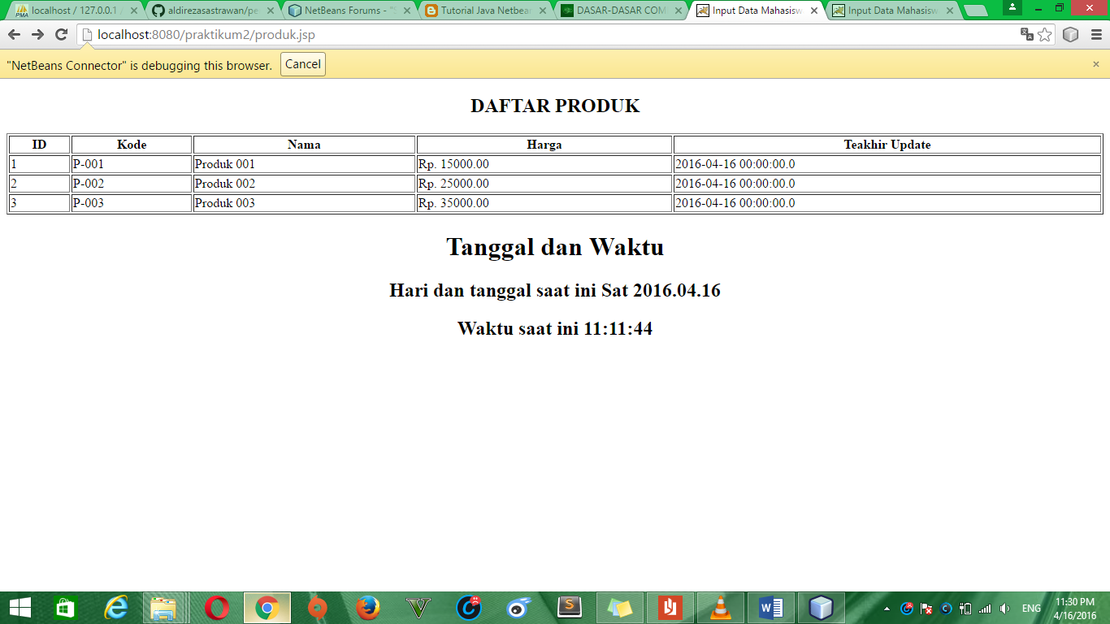

1. **Input data dan verivikasi data**

<!DOCTYPE html>

<!--

To change this license header, choose License Headers in Project Properties.

To change this template file, choose Tools | Templates

and open the template in the editor.

-->

<html>

<center>

<head>

<title>Input Data Mahasiswa</title>

<meta charset="UTF-8">

<meta name="viewport" content="width=device-width, initial-scale=1.0">

</head>

<body>

<h1>Input Data Mahasiswa</h1>

<form method="get" action ="scopedemo">

Nama : <input type="text" name="nama"/><br/>

Email : <input type="text" name="email"/><br/>

Tanggal Lahir : <input type="text" name="tgl"/><br/>

Alamat : <input type="text" name="alamat"/><br/>

<input type="submit" value="Simpan"/>

</form>

</body>

</center>

</html>

**ScopeDemoServlet.java**

import java.io.IOException;

import java.io.PrintWriter;

import javax.servlet.annotation.WebServlet;

import javax.servlet.http.HttpServlet;

import javax.servlet.http.HttpServletRequest;

import javax.servlet.http.HttpServletResponse;

/*

* To change this license header, choose License Headers in Project Properties.

* To change this template file, choose Tools | Templates

* and open the template in the editor.

*/

/**

*

* @author Aldi Reza Sastrawan

*/

@WebServlet("/scopedemo")

public class ScopeDemoServlet extends HttpServlet {

public void doGet(HttpServletRequest req, HttpServletResponse res) throws IOException {

String nama = req.getParameter("nama");

String email= req.getParameter("email");

String tgl= req.getParameter("tgl");

String alamat= req.getParameter("alamat");

res.setContentType("text/html");

PrintWriter output = res.getWriter();

output.println("<html>");

output.println("<head><title>Demo Scope HTTP</title></head>");

output.println("<body>");

output.println("<h1>Input Data Mahasiswa</h1>");

output.println("<h2>Nama :"+nama+"</h2>");

output.println("<h2>Email :"+email+"</h2>");

output.println("<h2>Tanggal Lahir :"+tgl+"</h2>");

output.println("<h2>Alamat :"+alamat+"</h2>");

output.println("<a href=\"/scopedemo\">Reload</a>");

output.println("</body>");

output.println("</html>");

}

}

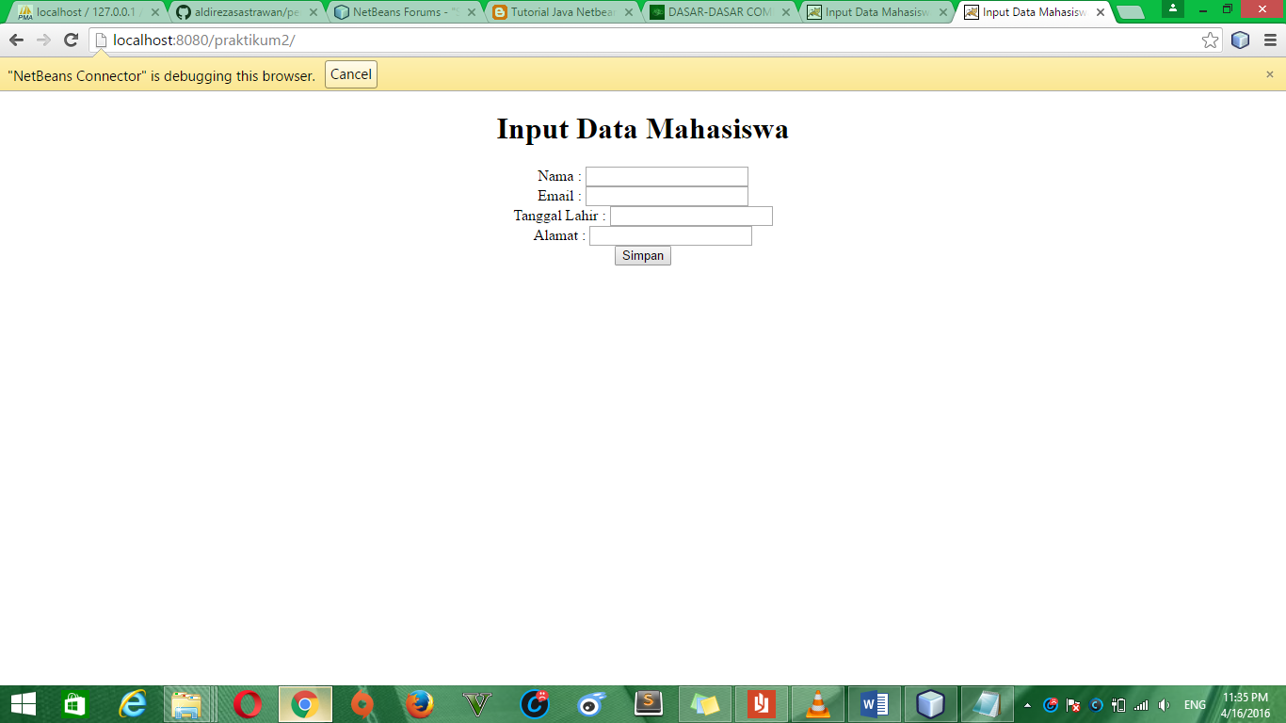

**Verivikasi Data Input di atas**

